# Assignment -3 Bucket and Watson assistant

|  |  |
| --- | --- |
| Assignment Date | 7 October 2022 |
| Student Name | SRIJISH R |
| Student Roll Number | 1905138 |
| Maximum Marks | 2 Marks |

**Questions:**

# Create a Bucket in IBM object storage.

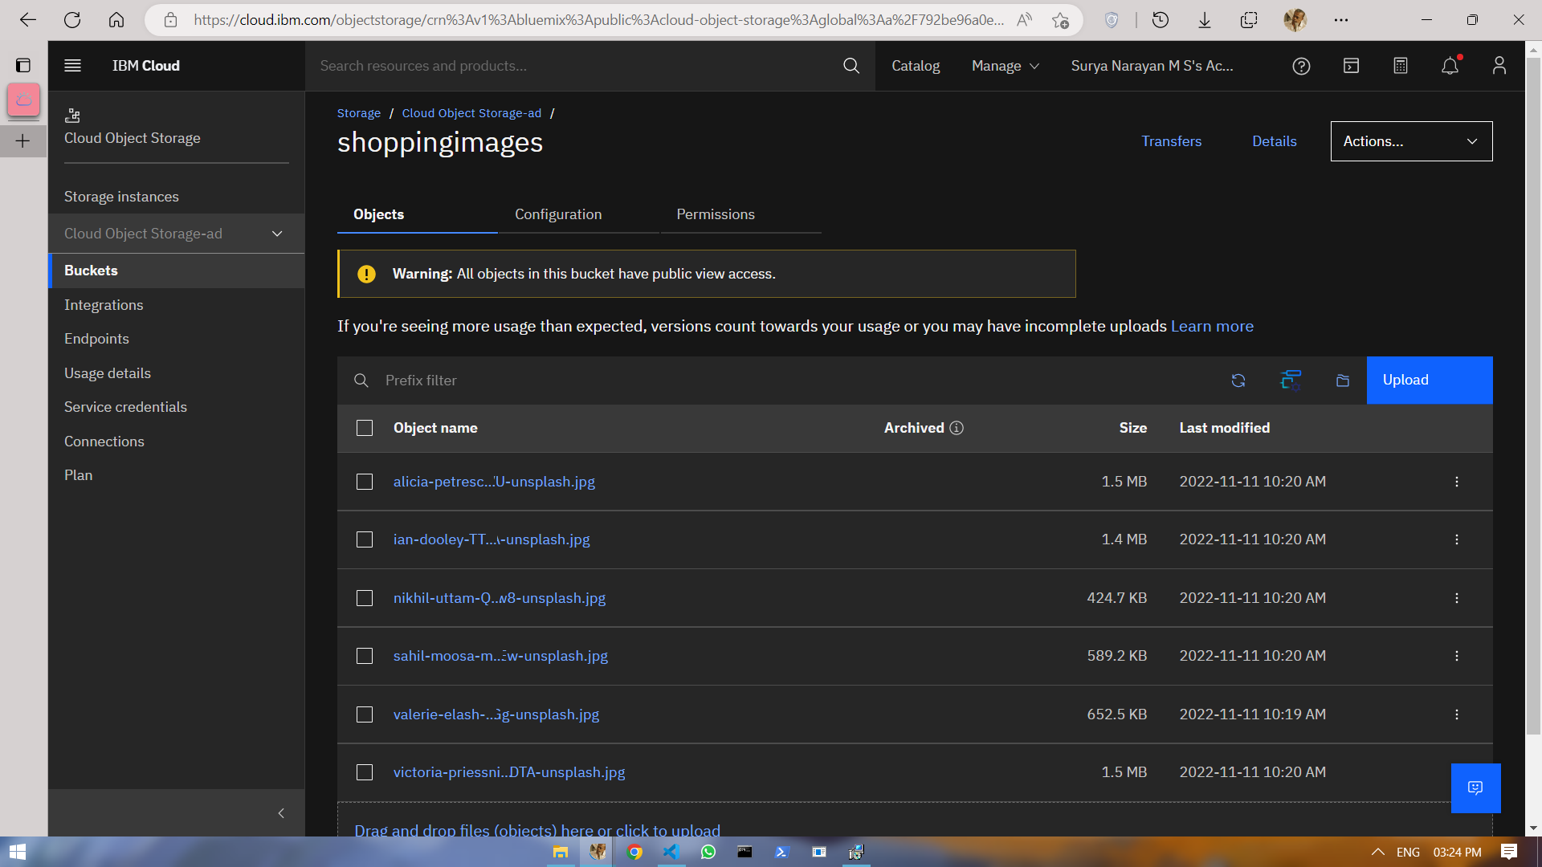

1. **Upload a 5 images to IBM object storage and make it public. Write html code to displaying all the 5 images.**

# Index.html

# 

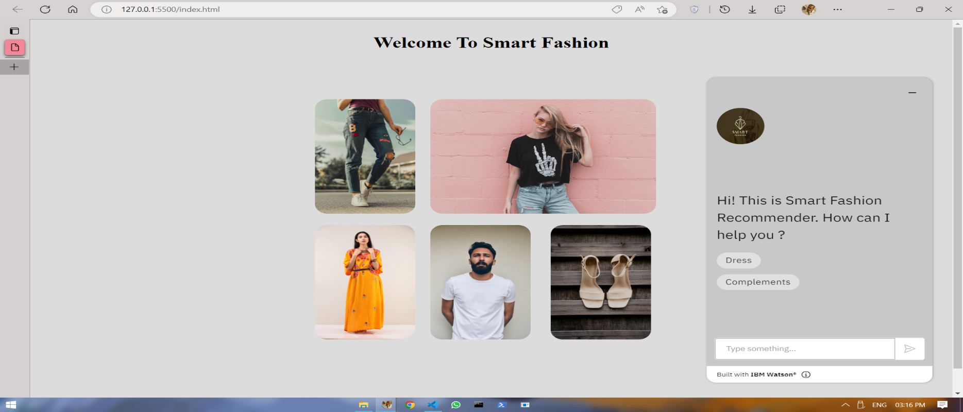

# Upload a css page to the object storage and use the same page in your HTML code.

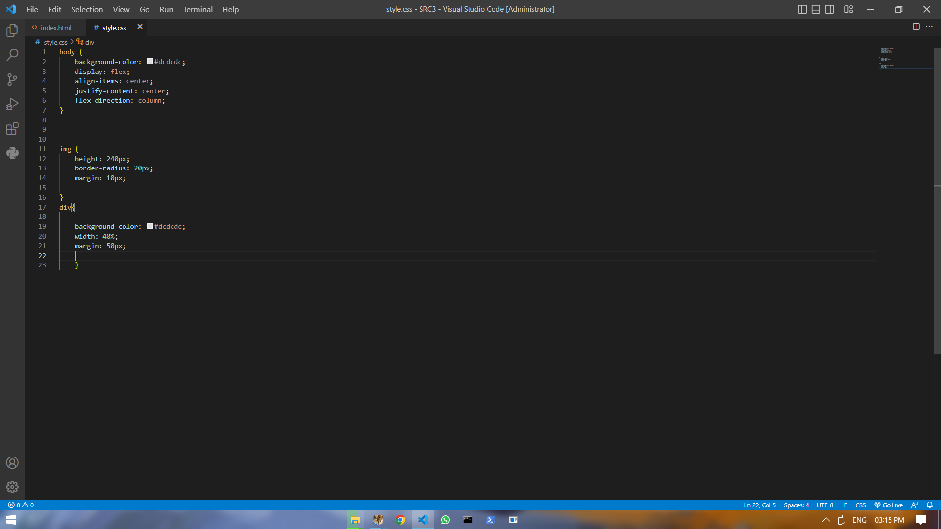

# Output:-

# 

1. **Design a Chabot using IBM Watson assistant for hospital. Ex: User comes with query to know the branches for that hospital in your city. Submit the web URL of that chat bot as an assignment.**

# Url :- [chatbot link](https://web-chat.global.assistant.watson.appdomain.cloud/preview.html?backgroundImageURL=https%3A%2F%2Feu-gb.assistant.watson.cloud.ibm.com%2Fpublic%2Fimages%2Fupx-efda1f12-ea7a-48aa-9c7e-02e5c36e9735%3A%3A4c863bfa-8c72-40e4-97e5-3b9c5d80eb12&integrationID=0850367d-4c3c-4131-b1ee-627f773ba47d&region=eu-gb&serviceInstanceID=efda1f12-ea7a-48aa-9c7e-02e5c36e9735) <- click Image:-

# 

**5 .Create Watson assistant service with 10 steps and use 3 conditions in it. Load that script in HTML page**



